**Ultra VNC installation on End System**

Run **UltraVNC_1_2_11_X86_Setup** setup Ok

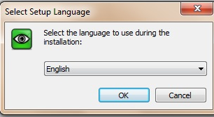

1. **Accept agreement** Next

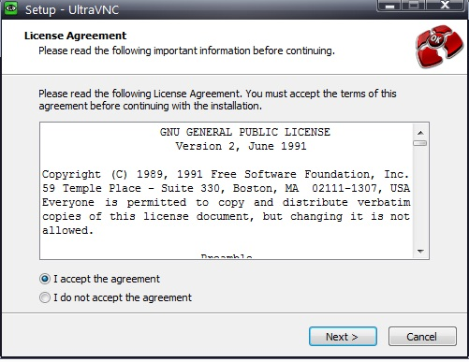

1. **Next**

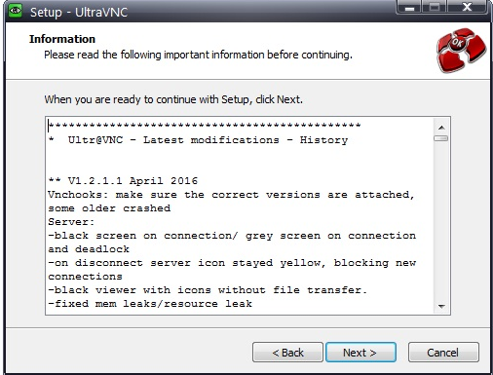

1. select **Ultra VNC server & Repeater**  Next

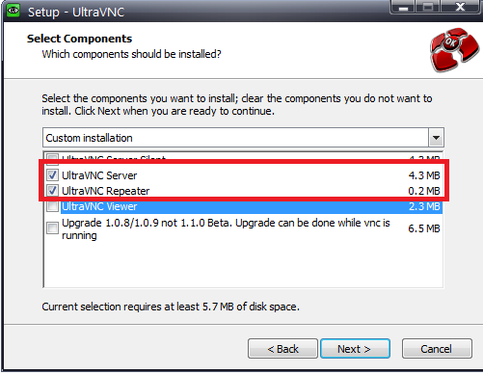

1. Select Below option Next

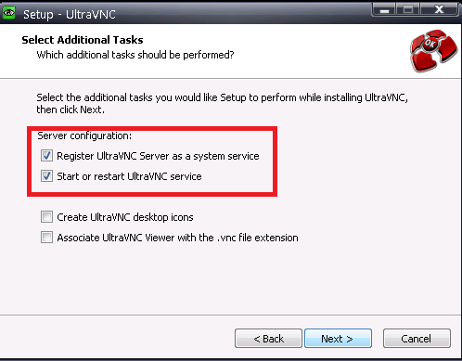

1. **Install**

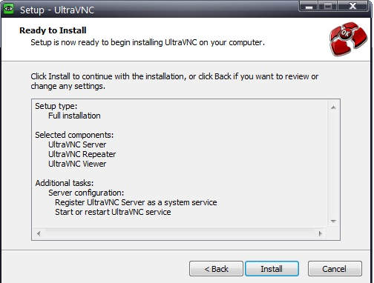

1. Next

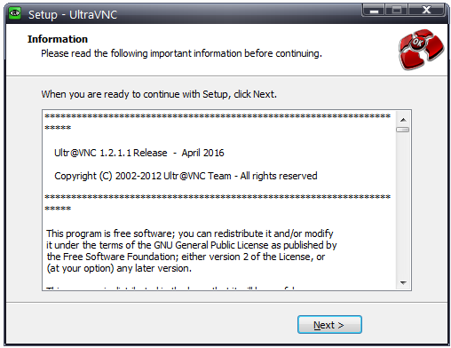

1. Finish(system will restart)

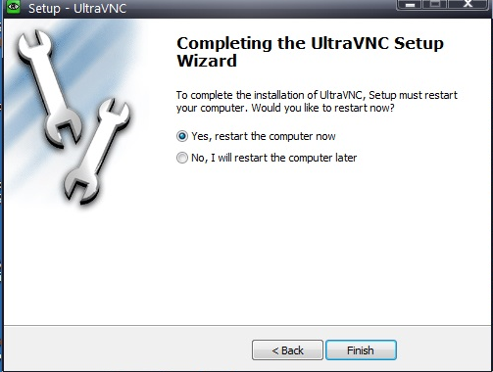

1. Right Click on icon showing below

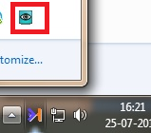

1. Close VNC Connections

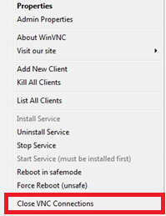

1. Copy **ultravnc.ini** &paste in below path.

Path - C:\Program Files\uvnc bvba\UltraVNC

1. Restart System

**Thank You**